Bank Loan Analytics & Risk Monitoring Project Report

Executive Summary
This project analyzes bank loan performance using SQL, Python, and Power BI. The objective was to monitor lending activities, evaluate portfolio quality, identify good and bad loans, and provide business insights through interactive dashboards.

Problem Statement
Develop a comprehensive loan reporting solution to track loan applications, funded amounts, collections, interest rates, DTI, and loan quality while enabling data-driven lending decisions.

Tools & Technologies
SQL Server, MS SQL, Python, Pandas, NumPy, Matplotlib, Plotly, Power BI, Excel

Project Workflow
Data Collection → Data Cleaning → SQL KPI Development → Exploratory Data Analysis → Power BI Dashboard Creation → Business Insights & Recommendations

SQL Analysis Performed
Developed SQL queries for Total Loan Applications, Funded Amount, Amount Received, Average Interest Rate, Average DTI, Good Loan vs Bad Loan Analysis, Loan Status Analysis, Monthly Trends, State Analysis, Loan Term Analysis, Employment Length Analysis, Purpose Analysis, and Home Ownership Analysis.

Python Visualizations

Monthly Funded Amount Trend
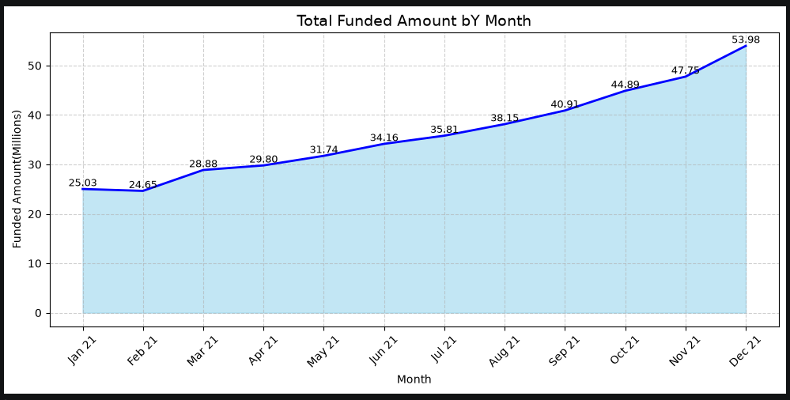

Monthly Loan Application Trend
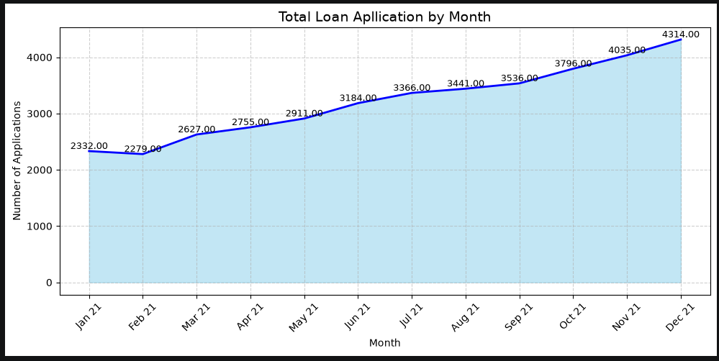

State-wise Funded Amount Analysis
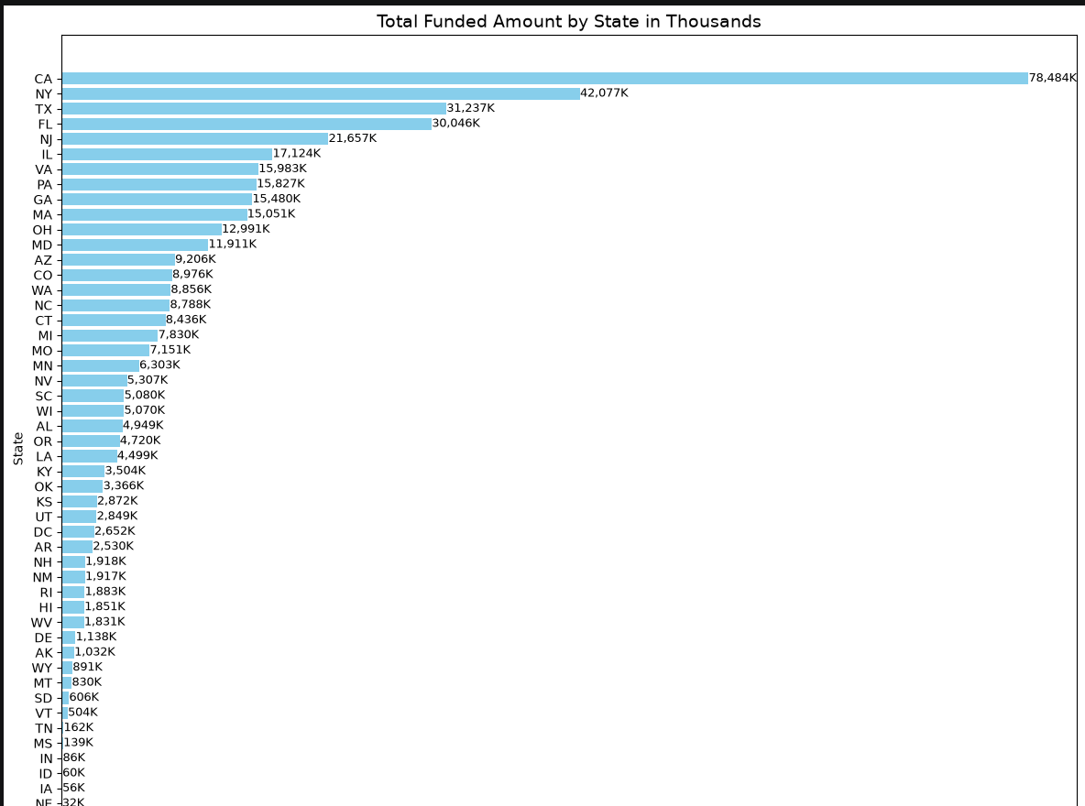

Loan Term Distribution
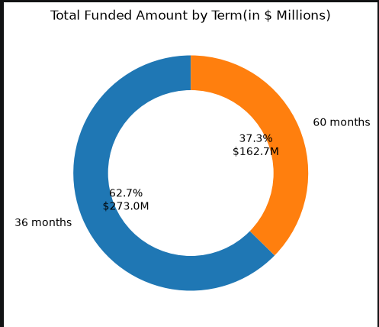

Employment Length to Loan Amount Relation Analysis
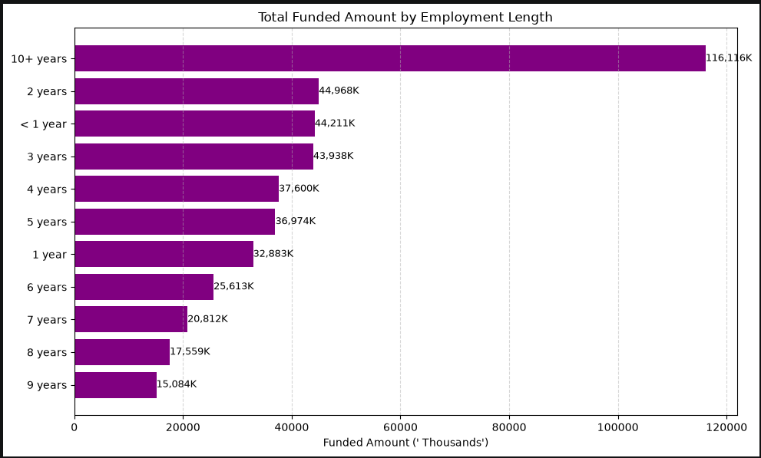

Loan Purpose Analysis
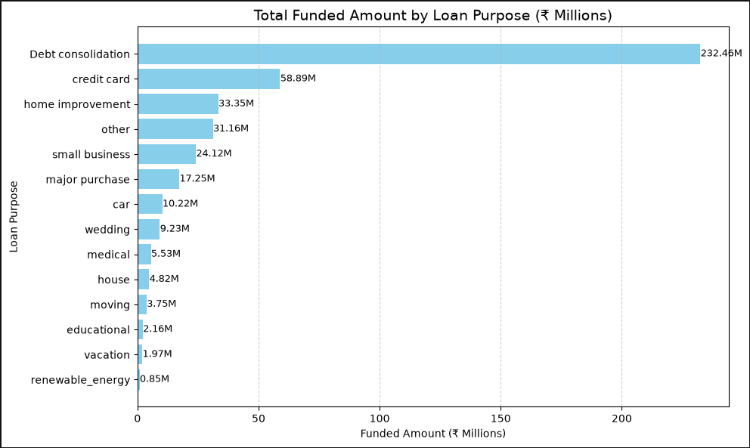

Power BI Dashboard - Summary
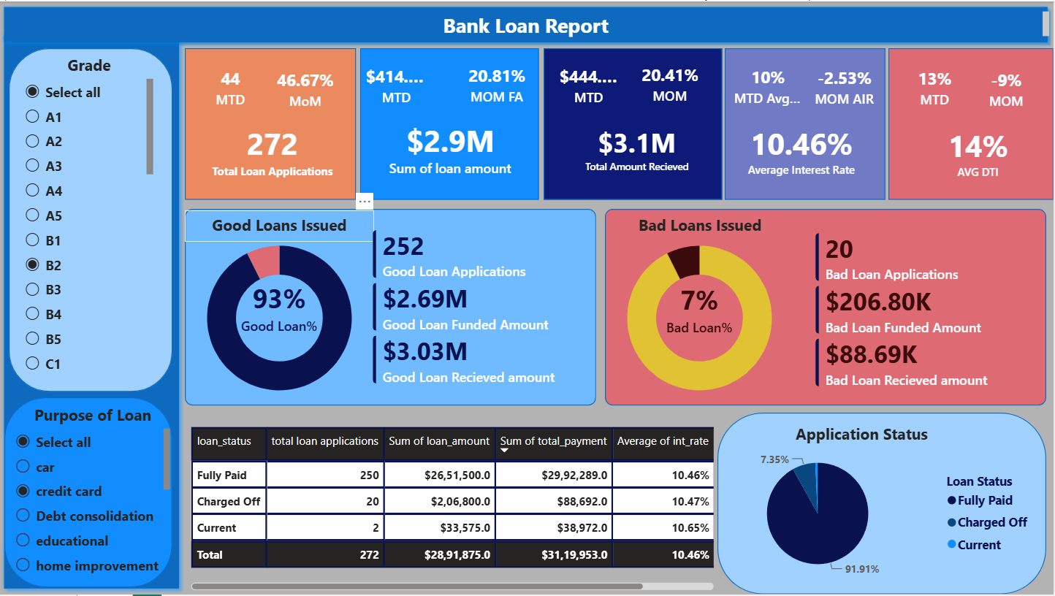

Key Business Insights
• Loan applications and funded amounts increased consistently throughout the year.
• December recorded the highest funded amount and highest number of applications.
• California, New York, Texas, and Florida contributed the largest share of loan funding.
• 36-month loans accounted for the majority of funded loans.
• Borrowers with 10+ years of employment tend to apply for highest amount of loans.
• Debt Consolidation was the dominant loan purpose category.
• Good loans significantly outweighed bad loans, indicating a healthy loan portfolio and less risk to the bank.

Skills Demonstrated
SQL: Aggregations, CASE statements, KPI reporting, filtering and grouping.
Python: Data Cleaning, EDA, Visualization, Pandas, NumPy.
Power BI: Data Modeling, DAX Measures, KPI Cards, Interactive Dashboards.
Business Analytics: Credit Risk Analysis, Loan Portfolio Monitoring, Financial Reporting.

Project Outcome
Built an end-to-end banking analytics solution that transforms raw loan data into actionable business insights for lending performance monitoring and risk assessment.

